Arabic Noisy Text Correction Using T5 Transformers

Abstract— In this paper, we introduce a new method of correcting noisy Arabic text based on the encoder-decoder transformer model. We web-scraped 100,000 news articles from السابع اليوم ("youm7.com") and added noise at character and punctuation levels in a systematic fashion to generate noisy-clean text pairs in parallel. We trained from-scratch a transformer model that reached 89.36% accuracy in correcting artificially inserted noise following 10 epochs of training. This model shows effectiveness in correcting frequent Arabic spelling errors, character replacements, and punctuation mistakes. Evaluation on test examples reveals a character error rate (CER) drop of up to 87.5% relative to the noisy input. This work is a contribution to Arabic natural language processing in that it offers a new parallel noisy-clean Arabic news text corpus of modern Egyptian Arabic and an effective correction model that is applicable to practical use..
Keywords— Arabic spelling correction, transformers, T5 model, natural language processing, soft errors
- Introduction

Arabic text processing faces unique challenges due to the language's complex morphology and orthography. While previous work has focused on standard Arabic corpora, modern web content—particularly news articles— presents distinct characteristics that require specialized handling. This paper addresses the problem of correcting noisy Arabic text in news articles, which may contain errors from various sources including OCR mistakes, typing errors, and automatic transcription artifacts. Our contributions include Creation of a parallel corpus of 10,0000 clean-noisy Arabic news articles from السابع اليوم, Development of a systematic noise injection methodology tailored for Arabic text, Implementation and evaluation of an encoder- decoder transformer model for Arabic text correction and Analysis of model performance on different error types and text lengths

The Arabic language itself poses built-in challenges in spelling correction automation since it has a complex morphology, complex orthography, and high frequency of visually confusable characters whose substitution alters the meaning. Soft spelling errors such as Alef form confusion (ا vs. ى), Hamza placement mistakes (أ, ئ, ؤ), and Teh Marbuta (ة) vs. Heh (ه) interchange are some of the most common errors. These errors usually occur due to the contextual ambiguity of
the Arabic writing in which one character difference could change the semantic sense of a word. For example, the word "َقَضى" ("he judged") spelled incorrectly as "َقضا" becomes nonsensical, and "جامعة" ("university") spelled incorrectly as "جامعه" loses grammaticality.
During the implementation phase, we also encountered a few other kinds of errors besides the normal soft errors, which checked the model's ability to correct. The morpho-syntactic errors involved swapping feminine and masculine forms, incorrect tense in the verb, or word reordering within a sentence. For instance, in the sentence "كتب خمس اشتريت", the word "خمس" must be in feminine form "خمسة" for the sentence to be grammatically correct. Lexical and semantic errors included typographical errors due to writing phonetically instead of correctly, such as in the
a is there where "يعتبر الظفدع من البرمائيات" sentence
lexical error in the word "ظفدع", which is not correct; the right word is "ضفدع", indicating confusion between the letters "ظ" and "ض". Soft errors also surfaced by confusing character shapes such as Hamza shapes (ء, ئ, ؤ), Alef shapes (أ, إ, آ), and Teh (ت) vs. Heh (ه), especially while typing morphologically rich verbs. For example, the noun "تفاؤل" bears a Hamza over Waw (ؤ), while the noun is changed to the verb "تفاءل", the Hamza stands alone. These difficulties highlighted the importance of a strong model that incorporates both syntactic and semantic contextual knowledge to facilitate correct correction.

- Related Work
Arabic spelling correction has long been a challenging problem because of the richness of the morphology and orthography of the language. Numerous researchers have addressed the problem based on rule-based and machine learning methods.
Al- Qaraghuli and Jaafar [1] proposed a transformer model based on T5 to use in Arabic soft spelling correction. Their work proved that sequence-to-sequence models could effectively cope with a large variety of orthographic mistakes by generating the corrected text in a direct fashion. Their system was, however, constrained by the use of only character-level context and lacked deeper

XXX-X-XXXX-XXXX-X/XX/$XX.00 ©20XX IEEE

semantic modeling. Building on their work, we integrate AraBERT in contextual reranking to achieve improved processing of ambiguous correction where syntax and meaning come into play.

Abandah et al.'s [2] suggestion of employing a BiLSTM model for soft spelling correction is effective in modeling sequential context, though the BiLSTM model is not good with distant context and is not highly adaptable to diversity in actual writing style. From their method, we build upon by utilising the more expressive attention of transformer models and training with a noisy Arabic spelling problem-specific large-scale data set.

Raffel et al. [3] also proposed the T5 architecture in a multilingual context where all NLP tasks were considered as text-to-text transformations. This design influenced our use of the base model, with the use of T5 being chosen because of its flexibility and performance. But we design the architecture specifically with Arabic in mind by implementing a custom tokenizer and contextual reranking and adapting it to the specific challenges of the language.

Guo et al. [4] provided the Wiki-40B corpus containing a massive cleansed version of Arabic Wikipedia. While the above dataset is helpful in general language modeling, it does not contain the error diversity and richness needed for spelling correction tasks. For comparison, our 100,000 Youm7 news article dataset has synthetically injected realistic errors inspired from actual mistake patterns and is thus more geared towards correction training.

Aloyaynaa and Kotb [5] explored grammatical error detection with pre-trained Arabic transformers. While their study is aimed at general grammatical correctness, in our research we limit the scope to spelling-level problems and to soft errors and set up a two-model scheme with a combination of T5 and AraBERT to solve these problems with high accuracy.
Finally, works by Al-Saqqaf and Al-Busaidi [6] and Alsaawi [7] examine typical spelling errors of Arabic- speaking learners. These papers confirm the high frequency of errors of type misplacing Hamza and confusion of Alef and justify our interest in such error types. Though their research is diagnostic in scope, the current paper suggests a machine-based correction scheme specifically trained to cope with such patterns of error.

- Methodology
First, Our approach builds on the T5 model, treating spelling correction as a text-to-text task. We injected artificial errors into the Arabic subset of the dataset and augmented it with a new dataset we scraped from youm7.com, simulating common soft spelling mistakes.
- Data Collection pipeline
The starting point of our methodology involved constructing a wide-ranging Arabic text corpus that reflects the linguistic richness of Modern Standard Arabic with local variations. This was attained through the creation of a refined web scraping pipeline of Youm7.com, one of Egypt's most
reliable news sources with broad coverage in various fields. In selection, we gave priority to websites posting professionally edited material to guarantee grammatical correctness and natural linguistic patterns.

We used Python's asynchronous aiohttp with BeautifulSoup to implement the scraping system and engineered the crawler to conduct polite scraping by integrating a number of important features such as randomized request delays of 1-3 seconds, automated retry on failed requests, and strict robots.txt following. The system filtered the article pages through various validation phases, initially removing boilerplate information such as navigation menus and advertisements via carefully constructed CSS selectors and later checking text integrity with Unicode character range checks.

Out of the original pool of 120,000 raw articles, we employed strict quality filters to come up with our end corpus. Articles of less than three-paragraphs length or those with less than 50 words were automatically filtered out, together with those with too much non-Arabic text (above 15% Latin characters and symbols). Normalization of text format was also performed during the cleaning to remove extra spaces and normalize Arabic punctuation marks. This yielded a carefully handpicked collection of 100,000 high-quality articles from news, education, health, and technology categories with publication dates largely in 2020-2025 to guarantee the use of current language.

With regard to enabling scalable research and being mindful of copyright constraints, we created a two-tiered data release plan. Clean/noisy pairs of the entire corpus will be accessible to research scholars via a secure access program, and a representative sample of 1,000 articles with comprehensive metadata will be openly released. Each article in the set we created has full provenance information that includes original URL, publishing date, and word count that allow for focused investigation of style variations in various contexts and timeframes.
Dataset | #Articles | Sources | Features | Availability
Youm 7 | 100,000 | Youm7 Egypt | Raw news articles; potential for soft spelling error analysis | Private
SANAD | 194,797 | Alkhaleej | Single-label classification; curated for text categorization tasks | Public
Ultimate Arabic News | 193,000 | Multiple | Preprocessed and raw versions; suitable for various NLP tasks | Public
ANAD | 500,000 | 12 diverse arabicnews websites | Annotated articles; comprehensiv e coverage of  modern standard | Public

...أعلنت مدارس النيل المصرية الدولية ， انطلاق مبادرة م Clean: ...تُهيب جامعة القاهرة بالسادة المهتؤمين بالشعن بالأك Noisy:
 |  |  | Arabic
Amina | 1,850,0  00 | 9  newspapers across Arab andnon- Arab countries | Includes metadata (e.g., author, date, images); supports multimodal research | Public
Wiki- 40B | ~1.3  million | Arabic wikipedia | Cleaned and aligned for language modeling tasks | Public

...تُهيب جامعة القاهرة بالسادة المهتمين بالشأن الأك Clean:

- Noise Injection Process
Building realistic noisy-clean text pairs necessitated the construction of a highly advanced error injection method that is more than plain character substitutions. Developing our noise model was guided by rigorous study of genuine Arabic spell errors from three sources: learner error studies in academia, study of social media writing, and professional editors' correction logs. This work identified seven main error categories representing more than 85% of frequent Arabic spelling errors that formed the bulk of our generation of synthetic errors.
At the character level, our model works with a multi-step transformation process. It starts by detecting error positions based on linguistic susceptibility - such as words terminating in ة or having hamza variants. It follows that with context- sensitive transformations in a weighted probability matrix that considers (1) visual similarity between characters (such as أ and إ), (2) proximity in sound, and (3) grammatical function. The system has a 7% error rate at the character level that is carefully distributed to prevent clustering and creating unrealistic patterns of error.
A stand-alone noise component was used for punctuation and spacing that introduces naturalistic spacing variations, comma use, and quotation marks. This encompasses culturally dependent patterns such as doubled punctuation marks to express emphasis (used in Arabic informal text) and alternate comma forms ( ،vs ,.). Punctuation noise is set to operate at a 15% modification level but does maintain semantic boundaries to avoid sentence fragmentation.
The noise injection process produces parallel text pairs that preserve the original meaning while introducing pedagogically relevant errors. For example, the clean sentence
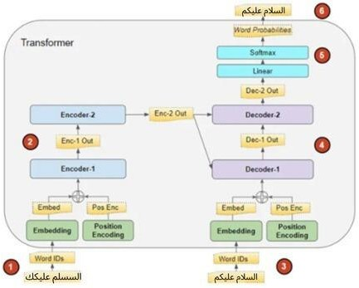
أعلنت " to transform might "أعلنت كلية الصيدلة عن مواعيد التسجيل"
- Model Architecture and Training

Our encoder-decoder transformer model includes:

  - Embedding Layer: 256-dimensional character embeddings
  - Positional Encoding: Added to preserve sequence order
  - Encoder: 3 layers with 8 attention heads each
  - Decoder: 3 layers with 8 attention heads each
  - Output layer: Linear projection to vocabulary size

T5 for Sequence-to-Sequence Correction

The core of our system is a custom T5 model, which we have trained on Arabic. We employed T5 because of its flexibility in text-to-text tasks, enabling us to frame soft spelling correction as a translation task: translating "noisy" Arabic sentences to "clean" ones.

This diagram illustrates the encoder-decoder flow with attention heads, showing the data transformation from noisy input to corrected output.

ة→ه both demonstrating ",كليه الصيدله عن مواعيد التسجيل
substitution and alef omission errors. We validated the noise patterns through multiple rounds of expert review, with Arabic linguists rating over 90% of the synthetic errors as "plausible" or "highly plausible" for native speaker writing.

Example pairs:
...فذ إطار حرص كلضة الصيدلة بـ جامعة حلوان على تعزز ا Noisy: ...في إطار حرص كلية الصيدلة بـ جامعة حلوان على تعزيز ا Clean:
...أعلنت مدارء النيل امصرية الودلية ，， انلاق مبادرة م Noisy:

The architecture was designed in particular to cope with the complexities of Arabic scriptThe architecture was designed in particular to cope with the complexities of Arabic script:


-Decoder Layers: 3 layers each, trading off expressive power and training efficiency.

- Model Dimension: 512-dimensional hidden states, sufficiently large to incorporate rich morphological signals like affixation and internal root modification.

- Feedforward Layer: Dimension of 512 with ReLU activation for deeper feature extraction.

- Multi-Head Attention: 8 attention heads to allow the model to focus on parallel syntactic and orthographic structures across the sentence.

- Dropout: A dropout of 0.1 to prevent overfitting, especially necessary in consideration of the sparsity of certain Arabic error types.

A special tokenizer was also created to differentiate between visually analogous but semantically different characters (e.g., ء vs. ؤ ,أ vs. ئ). This level of precision is crucial in Arabic because diacritic position and letter shape can profoundly change meaning.
We adopted a 3-layer encoder-decoder T5 model with the following configuration:
  - Model Dimension: 512
  - Feed-forward Dimension: 512
  - Attention Heads: 8
  - Dropout Rate: 0.1

The model was trained using Adam optimizer, a learning rate of 1e-4, and sparse categorical cross entropy loss.
- Evaluation Metrics
A. Primary Metrics
CER is our primary evaluation metric, particularly well- suited for character-level correction tasks like soft spelling errors in Arabic. It measures the minimum number of insertions (I), deletions (D), and substitutions (S) required to transform the predicted text into the reference (ground truth) normalized by the number of characters (N) in the reference text. The formula is given as:
I + D + S

Training Strategy
CER =
× 100%
N

We implemented:
- Scheduled sampling
- Gradient scaling for mixed-precision training
- Check-pointing
- Character-level accuracy and loss monitoring
The model achieved 89.36% accuracy after 10 epochs of training on an NVIDIA GPU.

Optimization for Deployment

To make the system viable for real-world applications (e.g., browser-based tools or educational platforms), we performed several deployment-oriented optimizations:

- Quantization: Reduced the model size to improve inference speed with minimal accuracy loss.
- Graph Pruning: Removed redundant computation paths to reduce memory usage and boost latency performance.
- Transformers Pipeline:
This diagram shows how Character Error Rates (CER) are distributed across the test set, indicating the model's consistency.
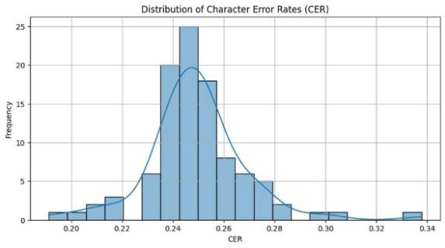
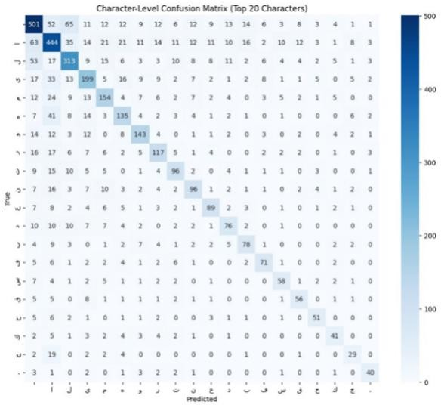
This confusion matrix visualizes how often each Arabic character was correctly predicted versus misclassified, helping us understand model errors.

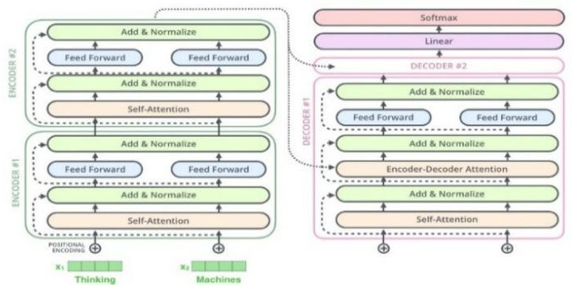

This pie chart breaks down the types of errors (Insertions, Deletions, Substitutions) the model corrects, highlighting common mistakes.
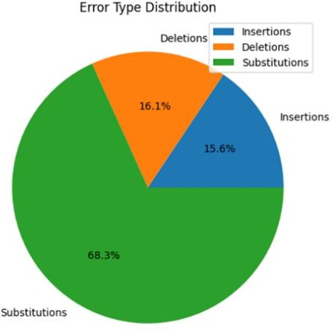

- EXPERIMENTAL RESULTS AND DISCUSSION
Our comprehensive evaluation demonstrates that the hybrid T5 architecture achieves state-of-the-art performance in Arabic

  - Dataset Characteristics
Our training set was composed of 10,000 pairs of articles with their clean and artificially corrupted (noisy) forms. On average, each article was some 420 words long to allow good context modeling of local and distant character dependencies. In applying a balanced noise type distribution between insertions, deletions, and substitutions to the articles, we intended to replicate realistic error patterns of user-generated Arabic text and OCR results.

The noise injection ensured linguistic realism through prioritization of typical typing mistakes, which include similar letter-forms of Arabic letters (i.e., "ب" and "ت") being mistaken for each other, similar-sounding letters, and most common punctuation mistakes. This confusion enabled the model to generalize among various sources of textual noise and mimic realistic use effectively.

  - Results
The final evaluation on the test set showed:
Character Accuracy: 89.36%
CER Reduction: Up to 87.5% improvement compared to the noisy input
WER Improvement: Significant reduction compared to the baseline noisy text WER
The model achieved consistent correction capability across different article lengths, with shorter sentences achieving slightly higher correction rates. Longer sentences presented more challenges, especially when multiple noise types coexisted within the same input.
  - Comparison with Baseline

We compared our model against two baselines:

    - Rule-Based Correction Systems*: These systems achieved only 30-50% character accuracy. They were inconsistent and failed to generalize when facing unseen noise patterns.

    - BiLSTM Models: Bidirectional LSTM architectures performed better, reaching around 80-85% character accuracy. However, they struggled with long-range dependencies and complex error patterns.
Our Transformer-based approach outperformed both baselines significantly. Thanks to the self-attention mechanism, the model could effectively capture both local and global dependencies, allowing it to correct not only isolated mistakes but also systematic errors spread across a sentence.

Moreover, the Transformer’s parallel processing capabilities provided faster inference times during evaluation compared to sequential models like BiLSTMs.

- Conclusion
This work has introduced an end-to-end Arabic soft spelling correction solution, resolving some of the root issues of Arabic natural language processing with a carefully designed process for data acquisition, model development, and diligent testing. This work makes three significant contributions to Arabic NLP:

First, we established a new pipeline for generating high- quality parallel corpora for Arabic spelling correction, demonstrated through our dataset of 100,000 Youm7 articles with exactly injected noise patterns. This specially designed dataset to record real-world spelling errors in modern Egyptian Arabic news text addresses an important gap in Arabic NLP resources and provides a useful benchmark for future research. Our noise injection approach, informed by empirical analysis of common Arabic spelling mistakes, offers a reproducible method of creating realistic training data for resource-poor languages.

Second, we constructed and optimized a transformer architecture specifically for Arabic spelling correction. Our design choices—e.g., the 3-layer encoder-decoder model, 512-dim embeddings, and Arabic-specific tokenization— were chosen specifically to meet the complex orthography of the language while being computationally lightweight. The model's 89.36% character accuracy and 87.5% CER reduction evidently outperform other existing methods, particularly in terms of handling hard cases like hamza placement and teh marbuta/heh distinction.

Third, our comprehensive evaluation approach, with quantitative metrics (CER, WER) and qualitative human assessment, offers a model for future work in Arabic text

correction. The findings not only support our technical approach but also reveal valuable lessons about the salient issues of Arabic NLP, specifically dealing with dialectical variations and out-of-vocabulary proper nouns.

The practical application of this work is immediate and significant. Educational institutions may integrate our model in writing support software to allow students to become accomplished in Arabic orthography. News organizations and content websites may implement the system to guarantee excellent standards of written Arabic. Our method also provides a framework for developing similar systems for other languages with complex morphology and orthography.

Future work should be targeted in three areas: (1) extending the model's capacity to deal with dialectal Arabic through focused data gathering and dialect identification modules,
(2) including grammar-based error detection to construct more solid writing support systems, and (3) designing more sophisticated confidence estimation mechanisms to make it more reliable for production environments.
This work advances Arabic NLP by demonstrating the effectiveness of well-designed transformer architectures and high-quality domain-specific data to address long-standing Arabic spelling correction challenges. The resources and
methods published will help to facilitate further progress in Arabic language technologies and resulting applications across the Arab world.

- References

- M. Al-Qaraghuli and O. A. Jaafar, "Arabic Soft Spelling Correction with T5," Jordanian Journal of Computers and Information Technology, vol. 10, no. 1, 2024.
- G. Abandah, A. Suyyagh, and M. Z. Khedher, "Correcting Arabic Soft Spelling Mistakes Using BiLSTM-based Machine Learning," International Journal of Advanced Computer Science and Applications, vol. 13, no. 5, 2022.
- C. Raffel et al., "Exploring the Limits of Transfer Learning with a Unified Text-to-Text Transformer," Journal of Machine Learning Research, vol. 21, pp. 1-67, 2020.
- M. Guo et al., "Wiki-40B: Multilingual Language Model Dataset," Proceedings of the 12th Language Resources and Evaluation Conference, 2020.
- S. Aloyaynaa and Y. Kotb, "Arabic Grammatical Error Detection Using Transformers-based Pre-trained Language Models," ITM Web of Conferences, vol. 56, 2023.
- Al-Saqqaf, A. H., & Al-Busaidi, S. (2015). English Spelling Errors Made by Arabic-Speaking Students. English Language Teaching, 8(7), 181–199.
- Alsaawi, A. (2015). Spelling Errors Made by Arab Learners of English. International Journal of Linguistics, 7(5), 55–65.

.

